Instructions to Input Screener Data to the Parent Portal
Literacy Screener

- Open the Parent Portal. Click on Staff
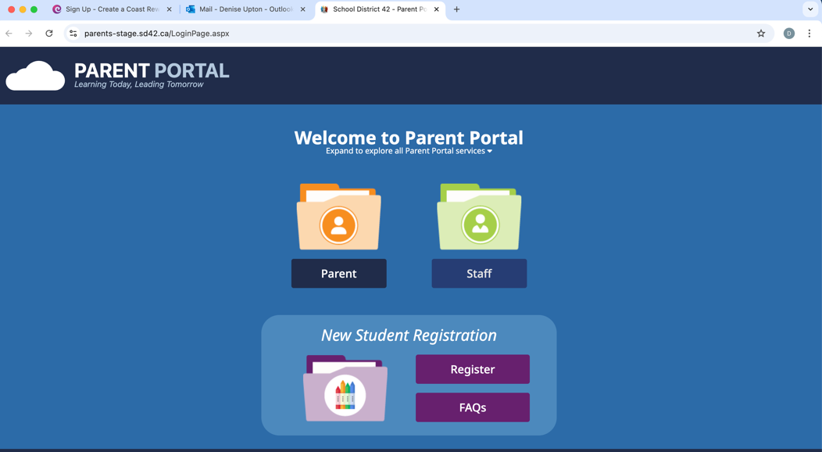

- Click on the Tools dropdown
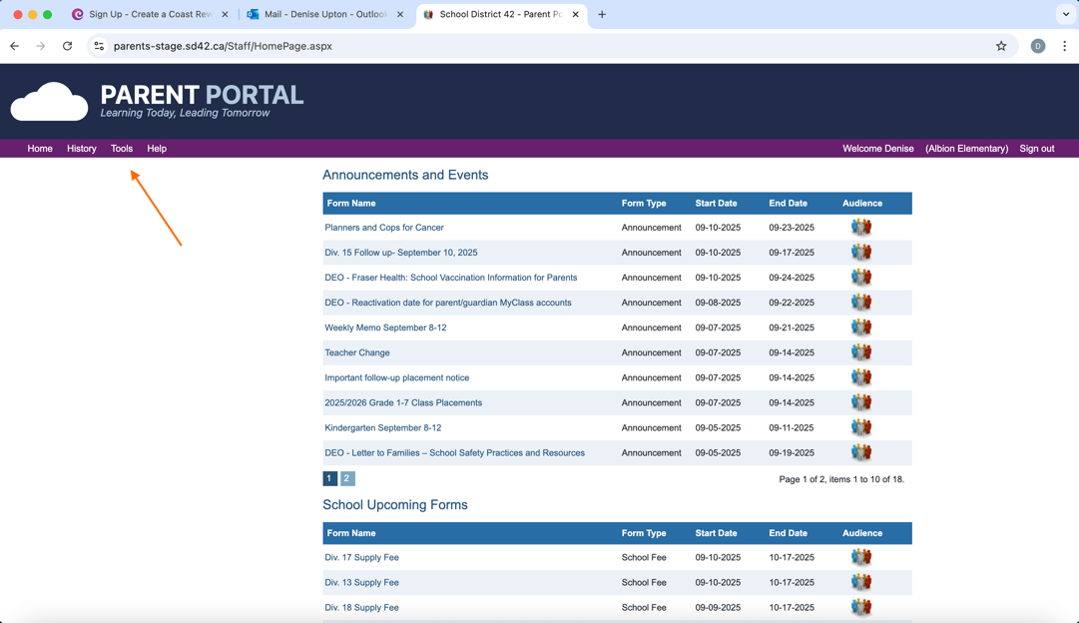

- Click on Assessments
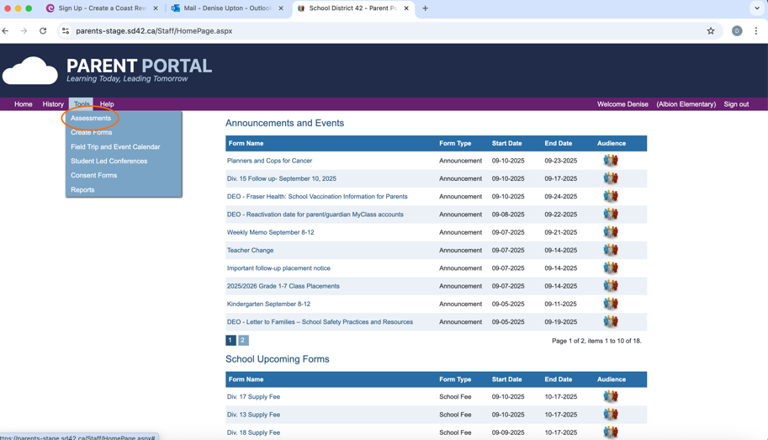

- Click on the Literacy Screener.
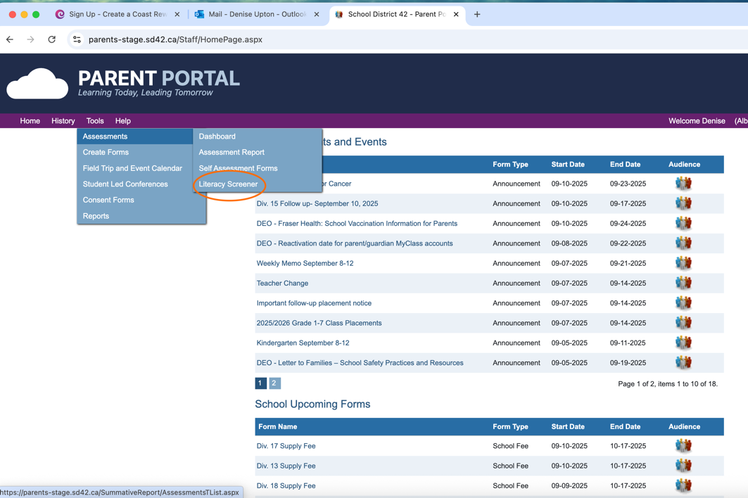

- Select current year, and division.
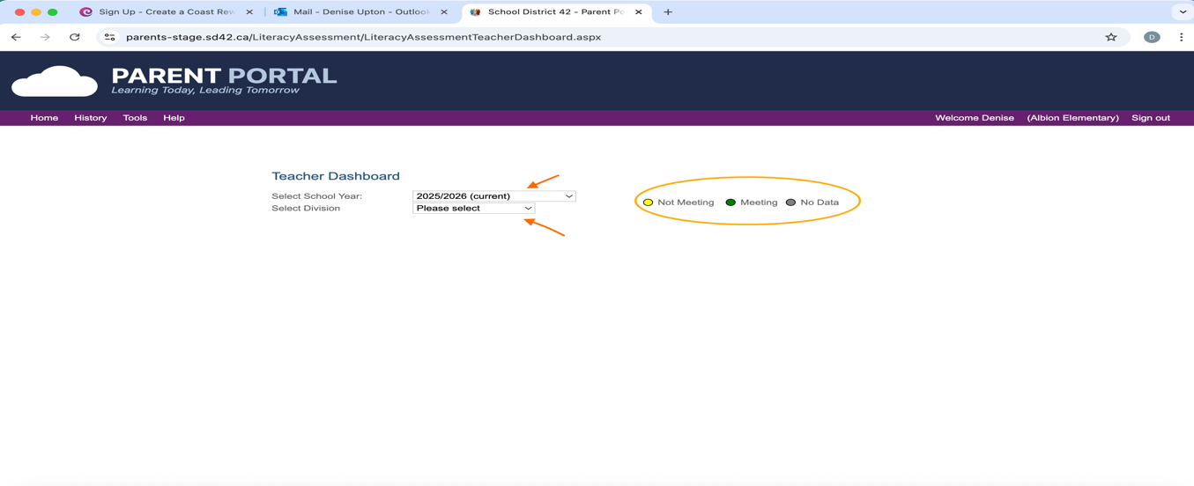
There are 3 codes for each student. You will be able to see if the student is currently not meeting benchmarks, meeting benchmarks, or no data has been entered.

- Select a student to input data by clicking on a grey dot.

- You are now on the student assessment page where you will be able to input data for all the terms. You will be able to see the last assessment score as well as each individual term score as well as the current benchmark status.
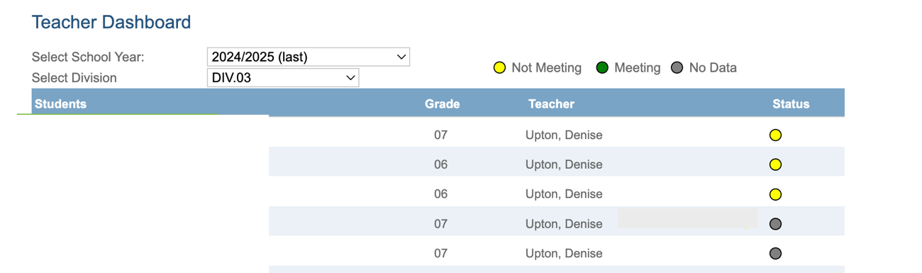
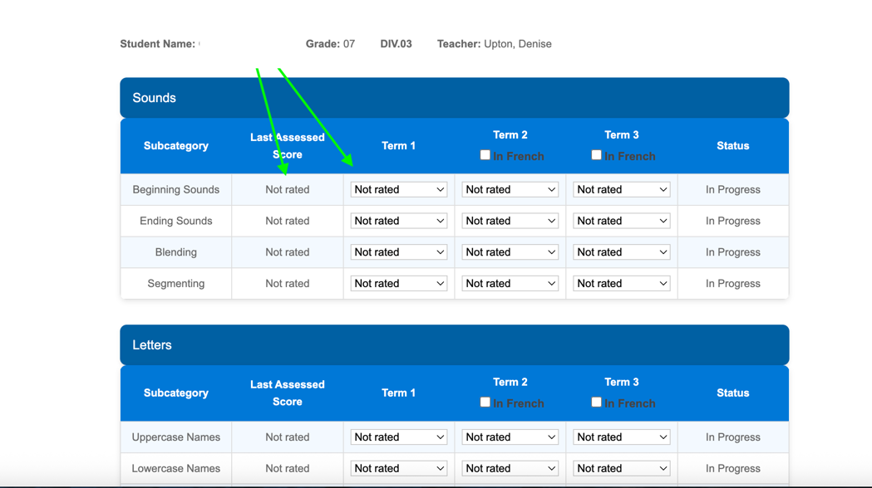

- Each section has a dropdown menu for you to select. Input data by choosing a number for each section. All K students will do the first term assessment in English.
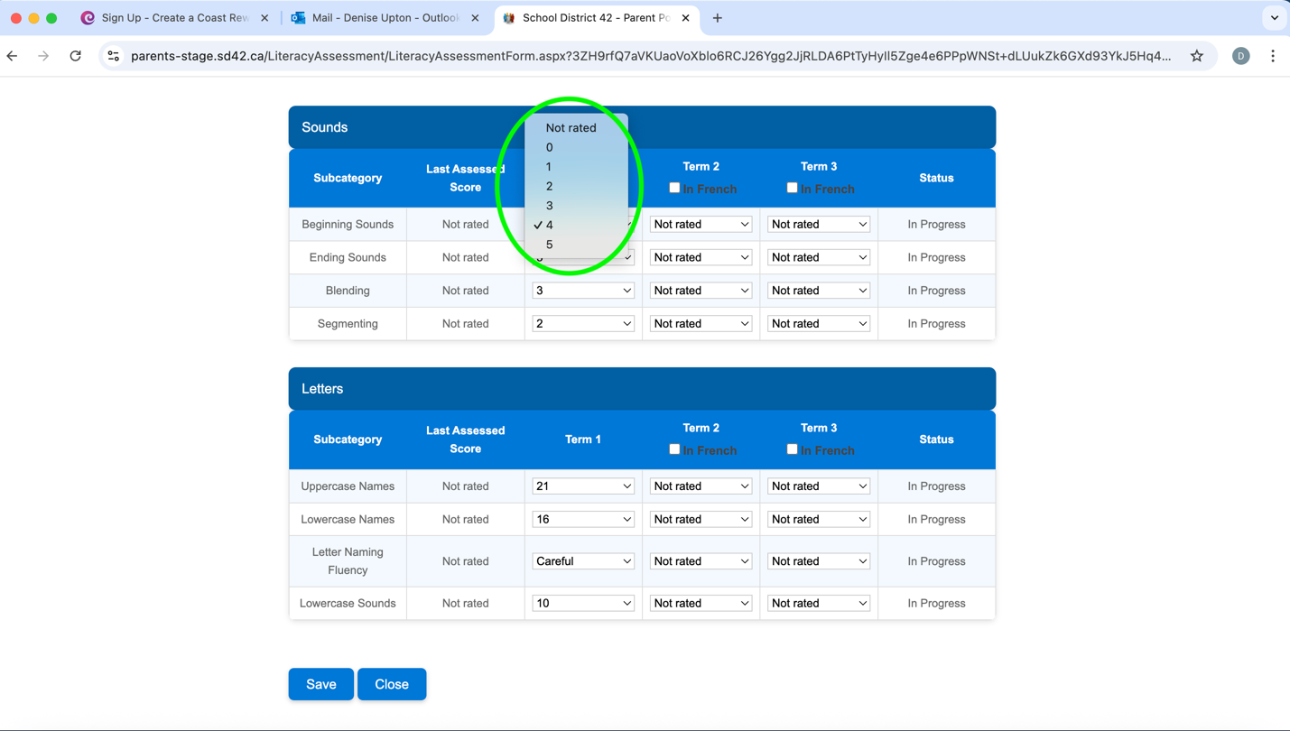
Close.
Save
Remember to click and after inputting all data for the term.
If you made a mistake, you can re-enter the data.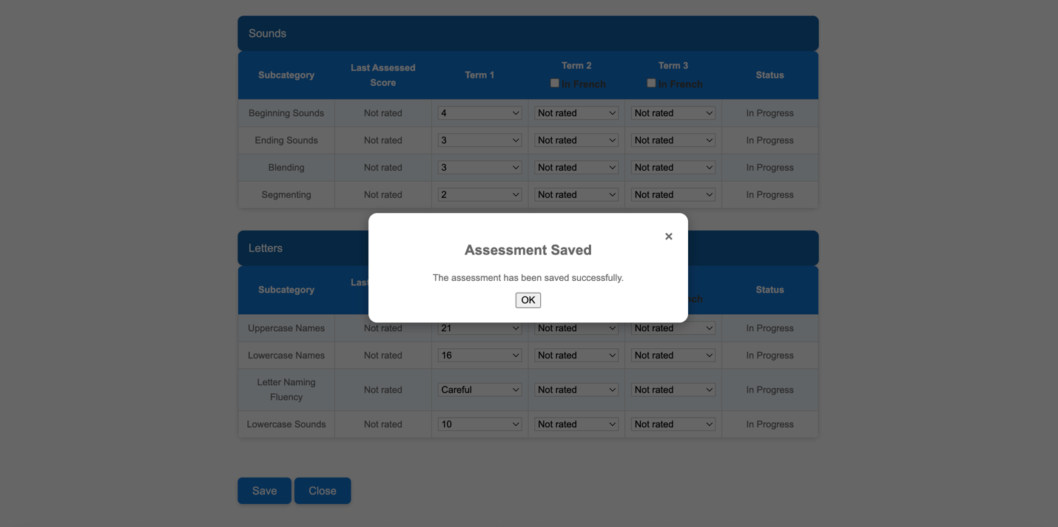
- For Term 2, French Immersion students will now do their assessment in French. Select In French for those students in both Sounds and Letters.
- Input all data for those sections that are in progress. If the status says Benchmark Met, you do not need to re-assess this section.
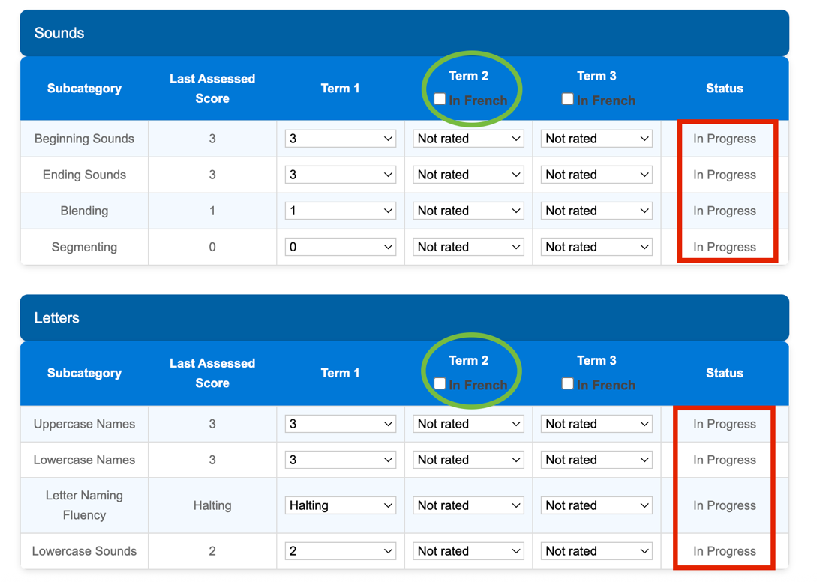
Closee
Save
Make sure to click and then .

- When all three terms have been inputted, you will be able to see all data in the Assessment Report.
Click on Tools.
Click on Assessments and then Assessment Reports
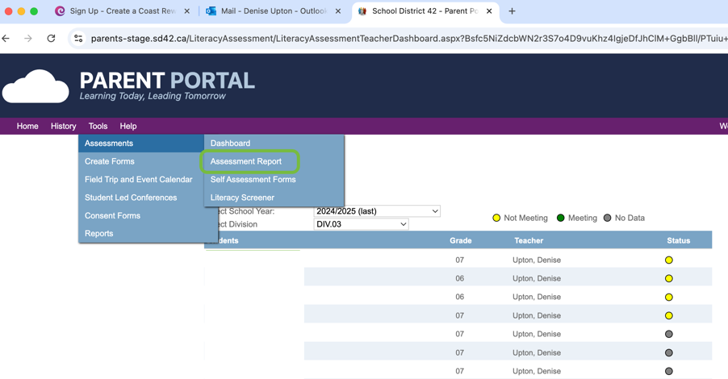

- Select your division
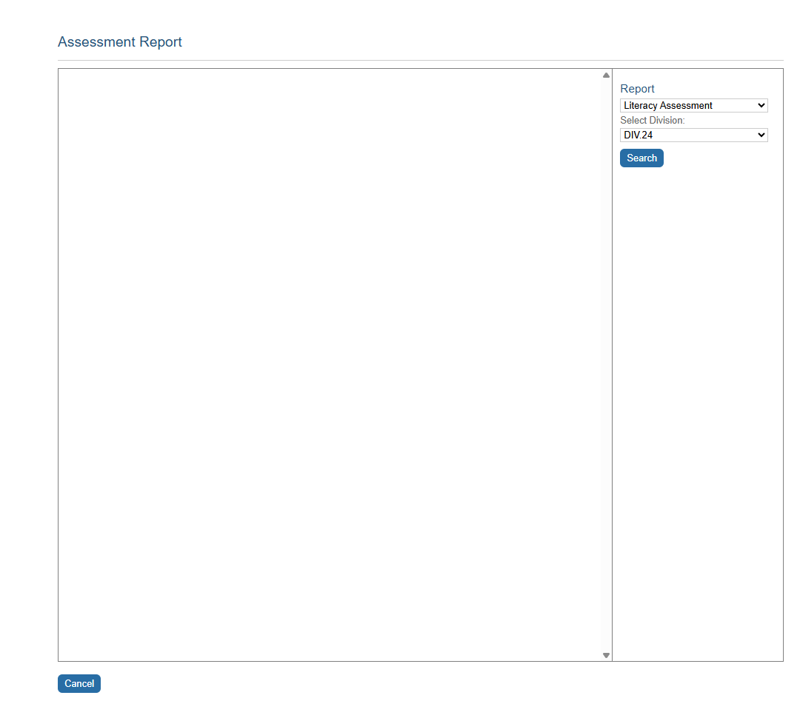

- You will be taken to a view of all data collected for you students.
You can click on areas to see more details.
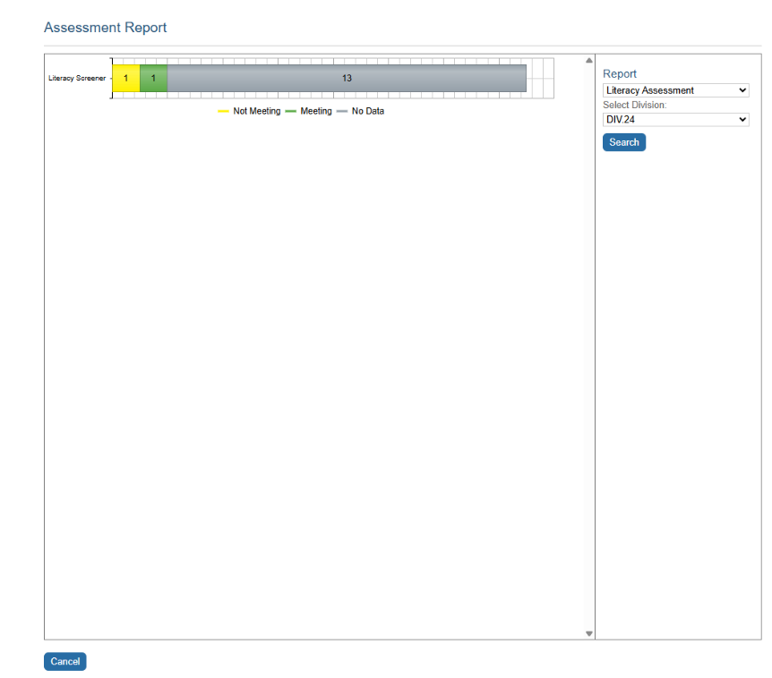

- You will be able to see all data for each sub-skill of the Assessment. This will show you how many students are in progress or have met the benchmarks for each sub-skill.
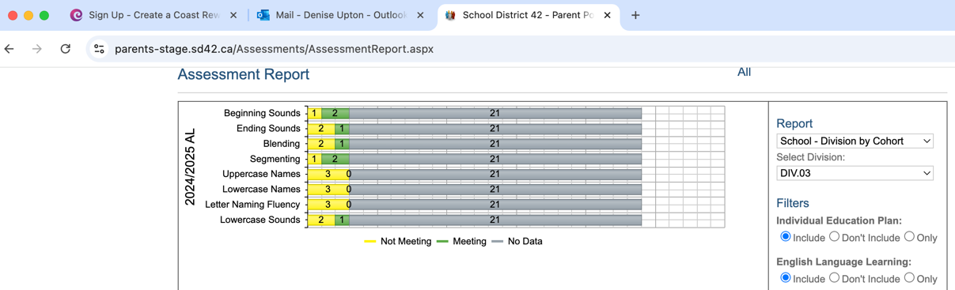
- By clicking on an area again, you will be able to see the exact final scores for each sub-skill.
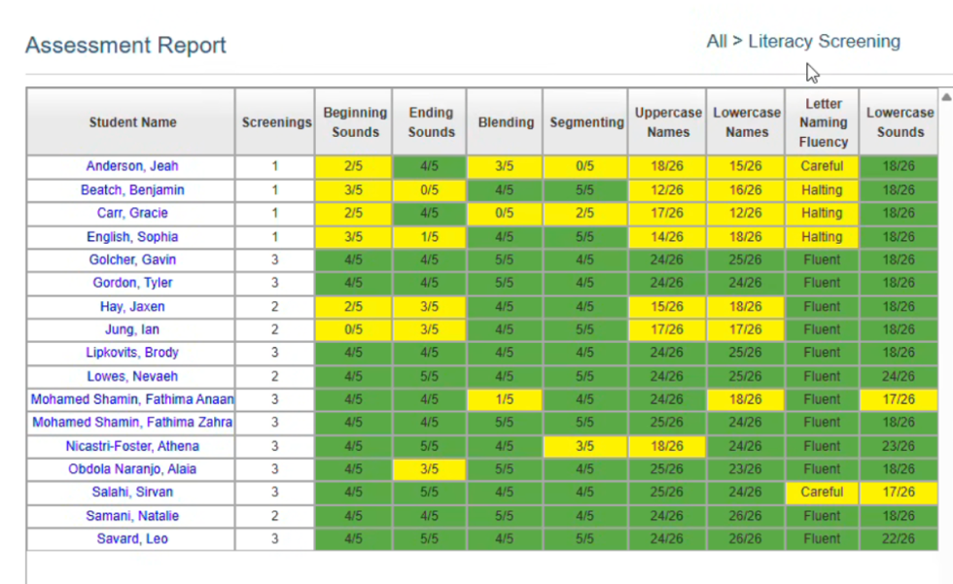

- By clicking on a student’s name, you will be able to see all 3 term assessment scores in all sub-skills for that student.
